EXP 6
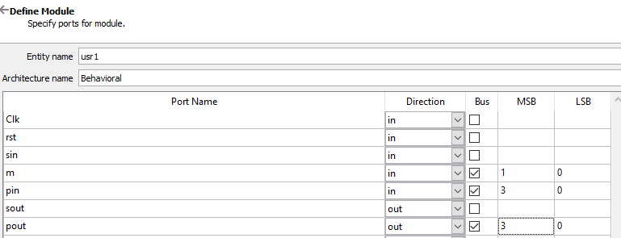
library IEEE;
use IEEE.STD_LOGIC_1164.ALL;
use IEEE.NUMERIC_STD.ALL;
use IEEE.STD_LOGIC_arith.ALL;
use IEEE.STD_LOGIC_unsigned.ALL;

entity usr1 is
Port ( Clk, rst, sin : in STD_LOGIC;
m : in STD_LOGIC_VECTOR (1 downto 0);
pin : in STD_LOGIC_VECTOR (3 downto 0);
sout : out STD_LOGIC;
pout : out STD_LOGIC_VECTOR (3 downto 0));
end usr1;

architecture Behavioral of usr1 is
signal p1,p2:std_logic_vector(3 downto 0);
signal s1:std_logic;
begin

process(clk,rst)
begin
if(rst='1') then
p1 <= "0000";
p2 <= "0000";
s1 <= '0';

elsif (clk'event and clk='1') then

if(m="00") then --SISO
p1(0) <= sin;
p1(1) <= p1(0);
p1(2) <= p1(1);
p1(3) <= p1(2);
s1 <= p1(3);

elsif(m="01") then --SIPO
p1(0) <= sin;
p1(1) <= p1(0);
p1(2) <= p1(1);
p1(3) <= p1(2);
p2 <= p1;

elsif(m="10") then --PIPO
p1 <= pin;
p2 <= pin;

else --PISO
p1(3) <= p1(2);
p1(2) <= p1(1);
p1(1) <= p1(0);
p1(0) <= '0';
s1 <= p1(3);

end if;

end if;
end process;

pout <= p2;
sout <= s1;
end Behavioral;
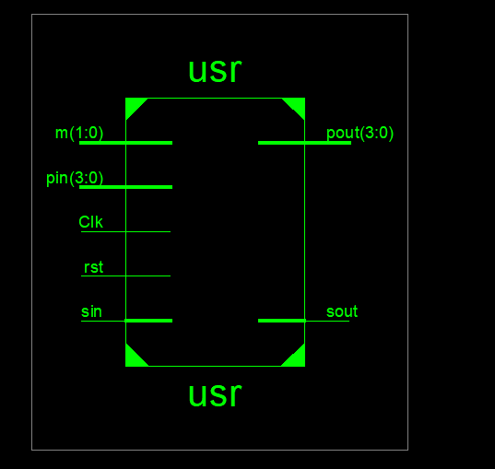

Test bench code
library ieee;
use ieee.std_logic_1164.ALL;

entity usr_tb is
end usr_tb;

architecture behavior of usr_tb is

-- Component Declaration
component usr1
port(
Clk : in std_logic;
rst : in std_logic;
sin : in std_logic;
m : in std_logic_vector(1 downto 0);
pin : in std_logic_vector(3 downto 0);
sout : out std_logic;
pout : out std_logic_vector(3 downto 0)
);
end component;

-- Inputs
signal Clk : std_logic := '0';
signal rst : std_logic := '0';
signal sin : std_logic := '0';
signal m : std_logic_vector(1 downto 0) := (others => '0');
signal pin : std_logic_vector(3 downto 0) := (others => '0');

-- Outputs
signal sout : std_logic;
signal pout : std_logic_vector(3 downto 0);

-- Clock period
constant Clk_period : time := 20 ns;

begin

-- UUT Instantiation
uut: usr1 port map (
Clk => Clk,
rst => rst,
sin => sin,
m => m,
pin => pin,
sout => sout,
pout => pout
);

-- Clock process
Clk_process : process
begin
Clk <= '0';
wait for Clk_period/2;
Clk <= '1';
wait for Clk_period/2;
end process;

-- Reset process
rst_process : process
begin
rst <= '1';
wait for Clk_period;
rst <= '0';
wait;
end process;

-- Stimulus process
stim_proc: process
begin

-- SISO
pin <= "1001";
sin <= '1';
m <= "00";
wait for 120 ns;

-- SIPO
pin <= "1101";
sin <= '1';
m <= "01";
wait for 120 ns;

-- PIPO
pin <= "1101";
m <= "10";
wait for 120 ns;

-- PISO
pin <= "0100";
m <= "11";
wait for 120 ns;

wait;

end process;

end;
